My Health Helper - Doctor Patient Requests

**Description**

This feature allows health care professionals to request to be the primary doctor of a patient. The feature allows doctors to more easily manage their patients. Changes shall be made to two of the existing web pages, these being the patient select screen for doctors and the doctor select screen for patients. The doctor will be presented with a list of patients not registered to them and be able to send requests to these patients. These requests will then be shown to the patient when they are logged in and viewing the change doctor screen. They will have the choice of accepting or cancelling the request. If they accept the doctor who sent the request will become their primary health care expert and be able to view their information.

**Development**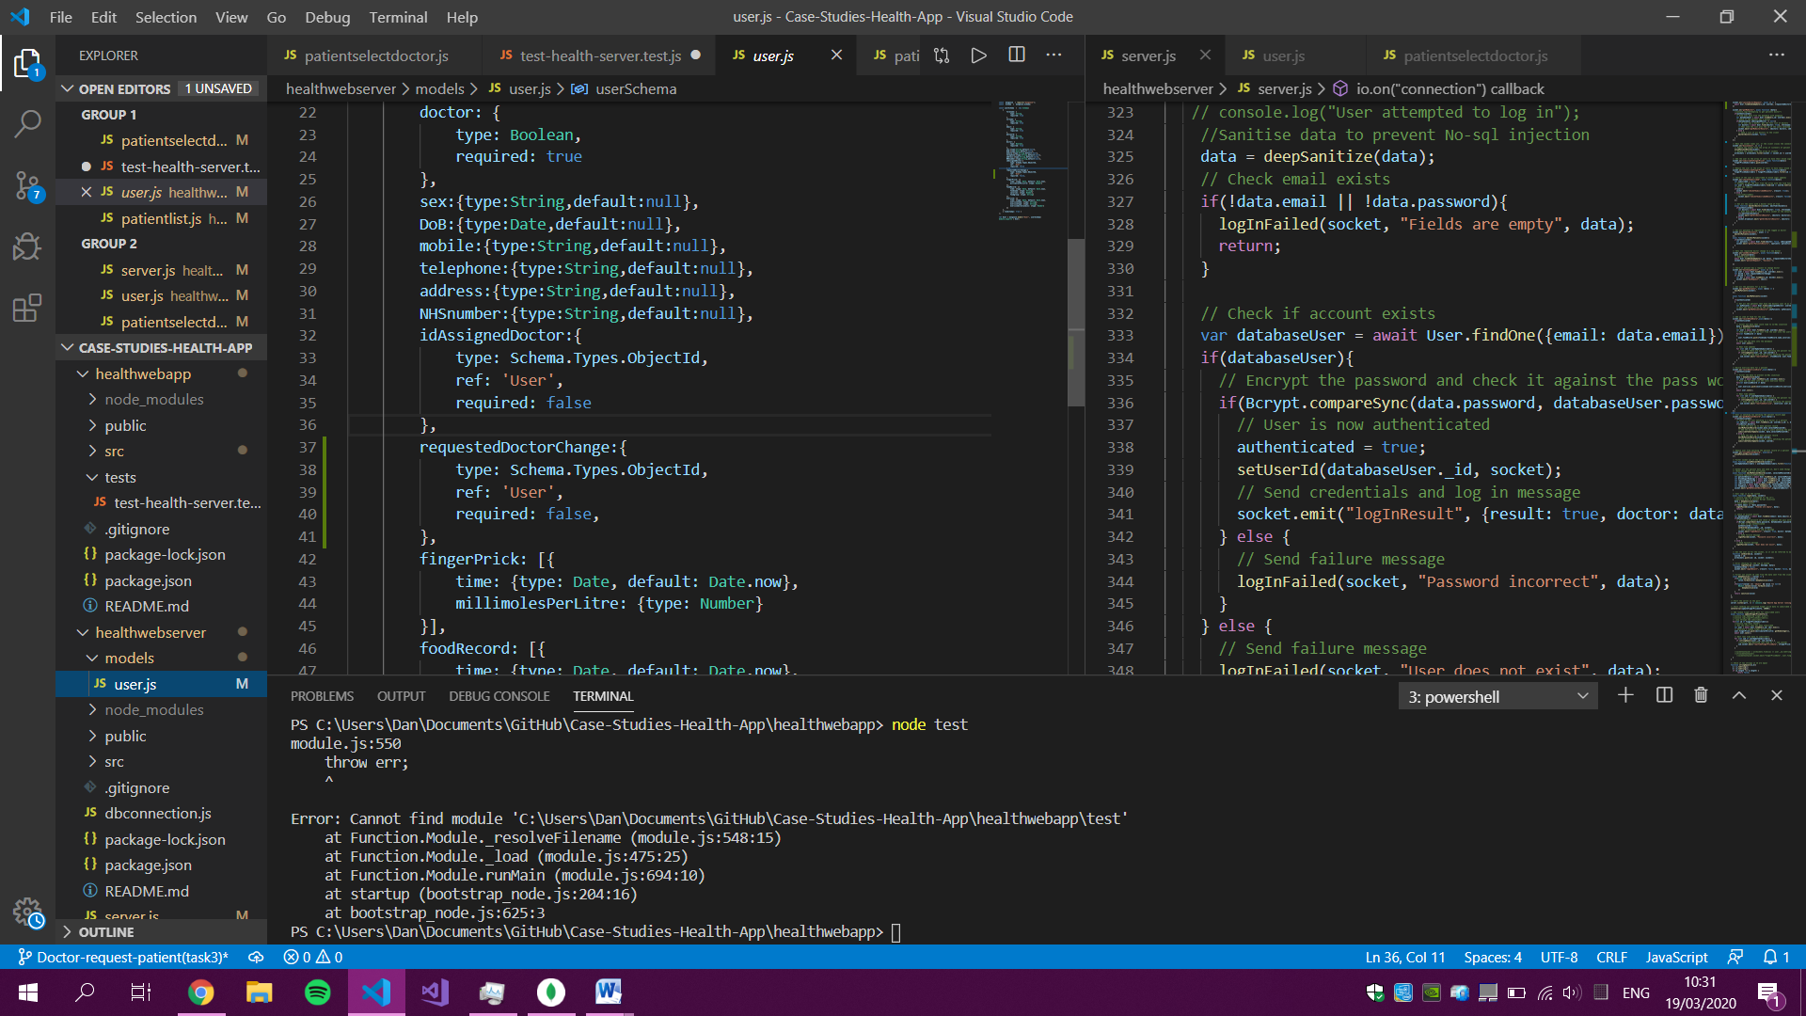

The first step was an additional field added to the user model that would hold the id of the doctor who has sent the request.

The doctors’ view my patients page was then updated to list all patients.

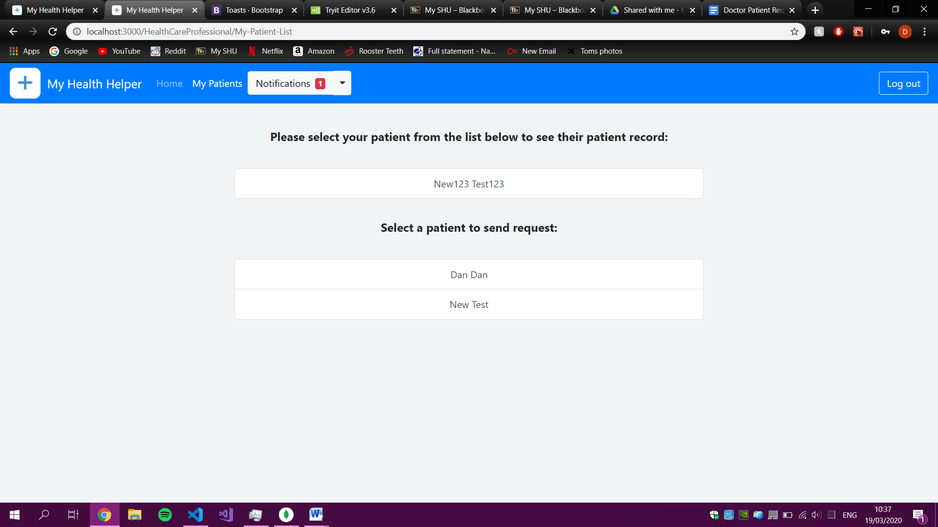

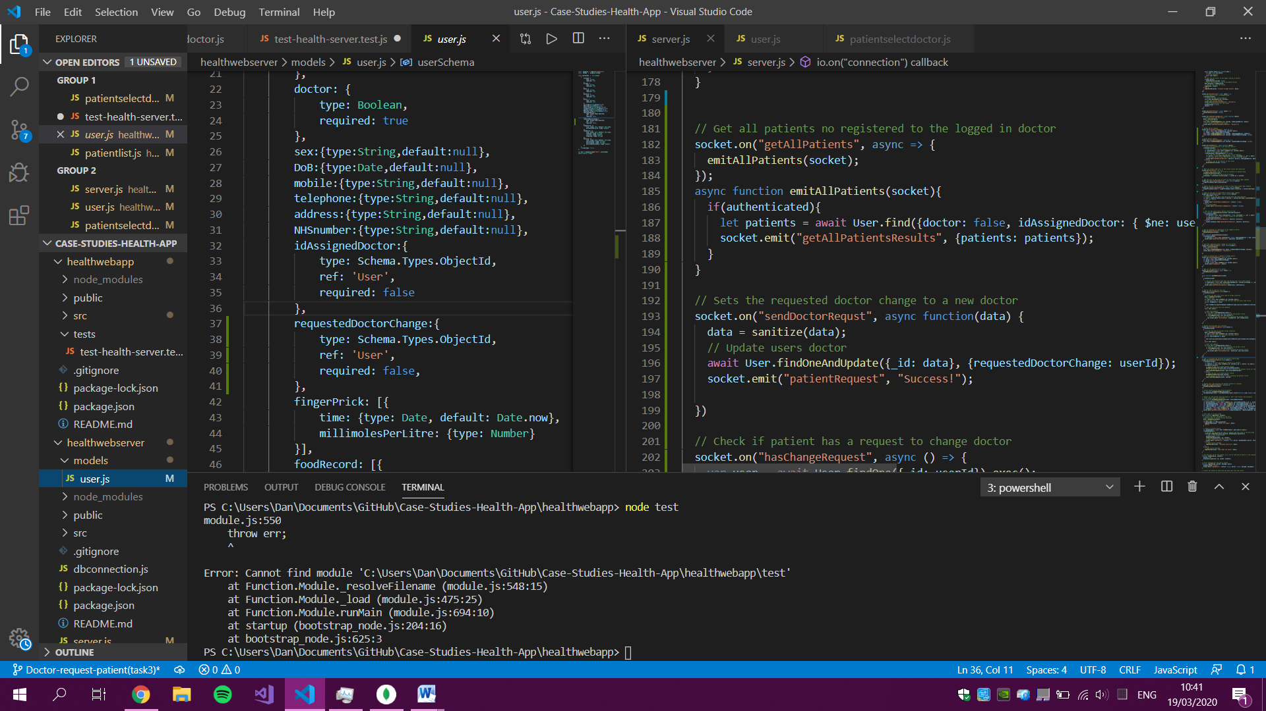

Server side functions added to list all patients not assigned to the current doctor and to send requests to these patients.

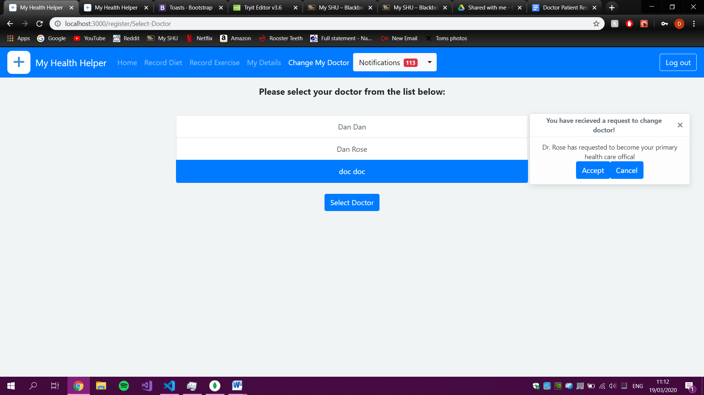

A bootstrap toast message is used to notify the patient that they have a request.

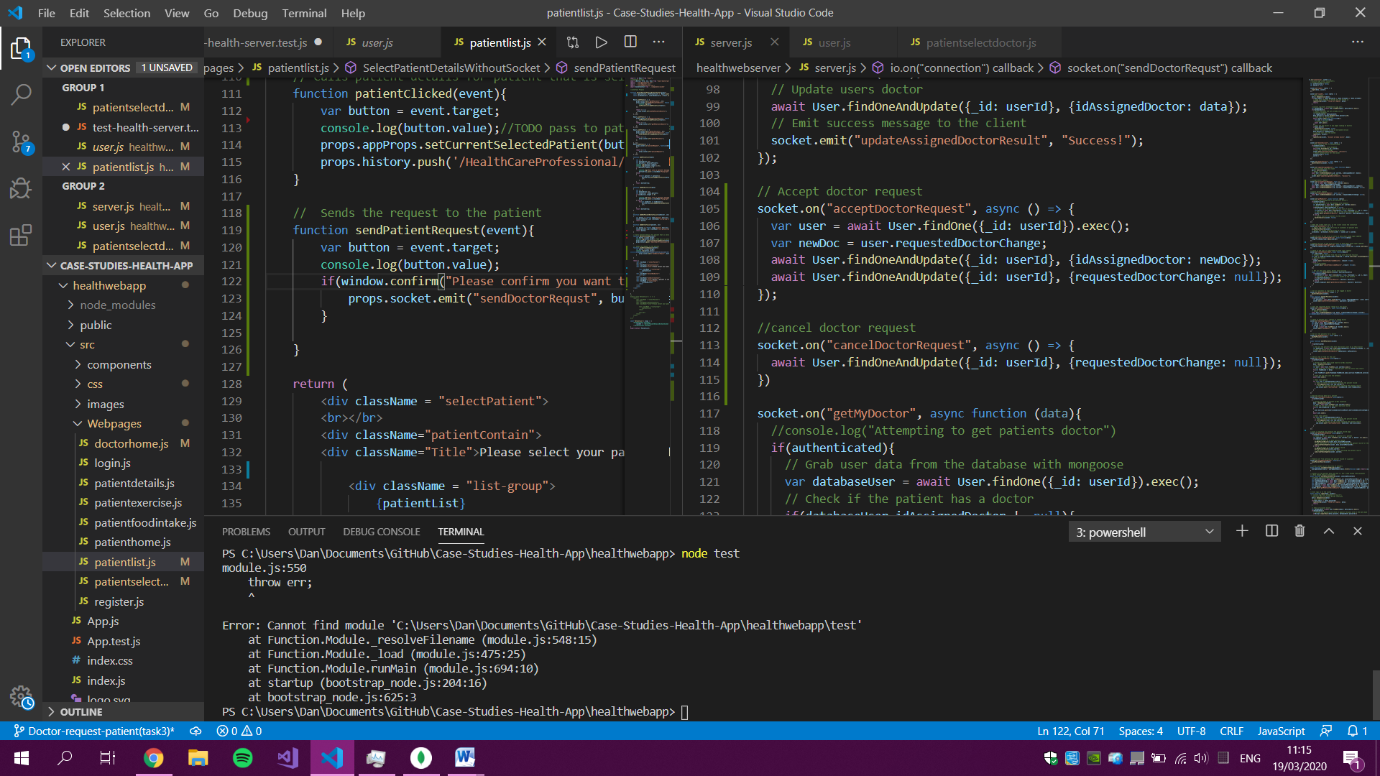

Server side functions for accepting and canceling doctor requests.

**Testing**

To test the new additional functions, several new unit tests were written and ran.

**Test 1 - Sending a request**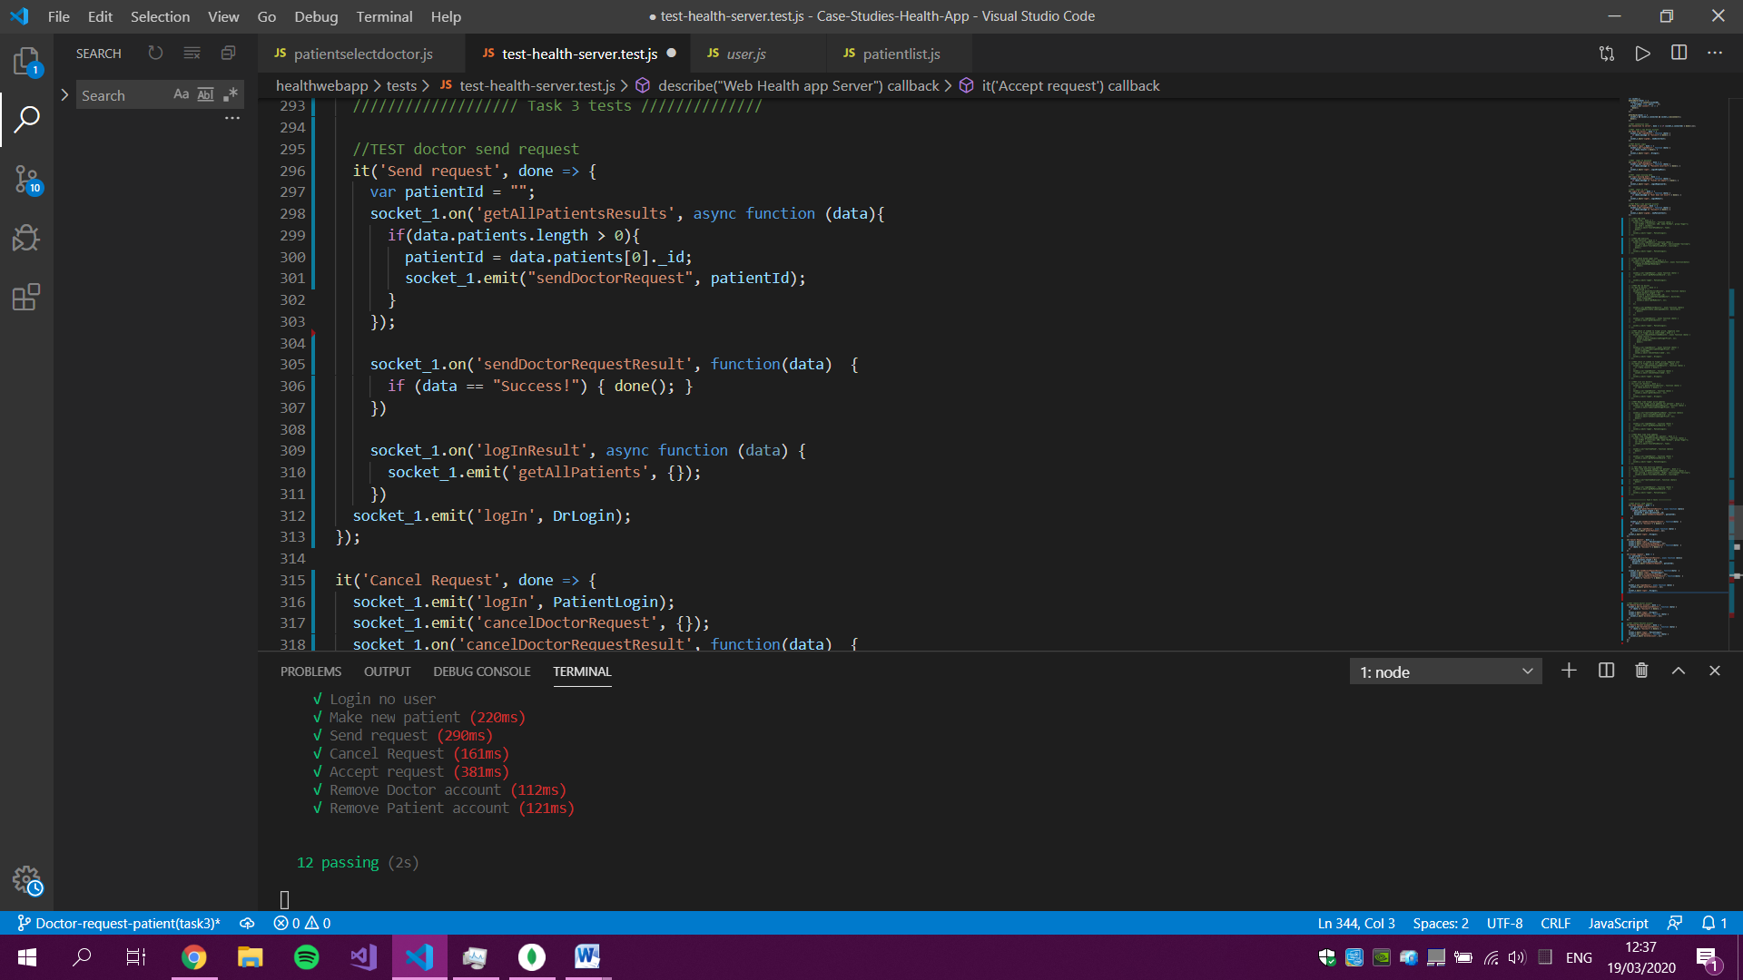

**Test 2 - Canceling the request**

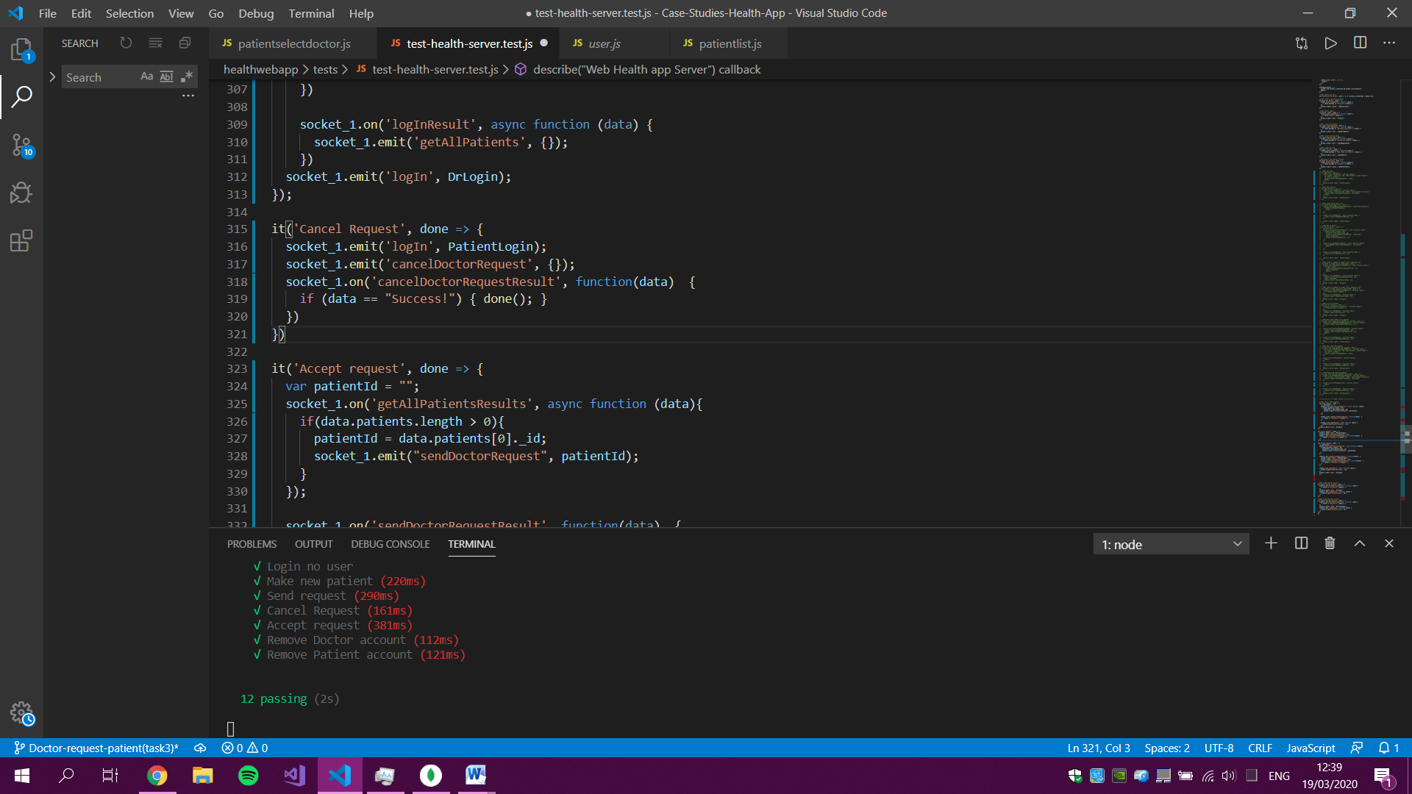

**Test 3 - Accepting the request**

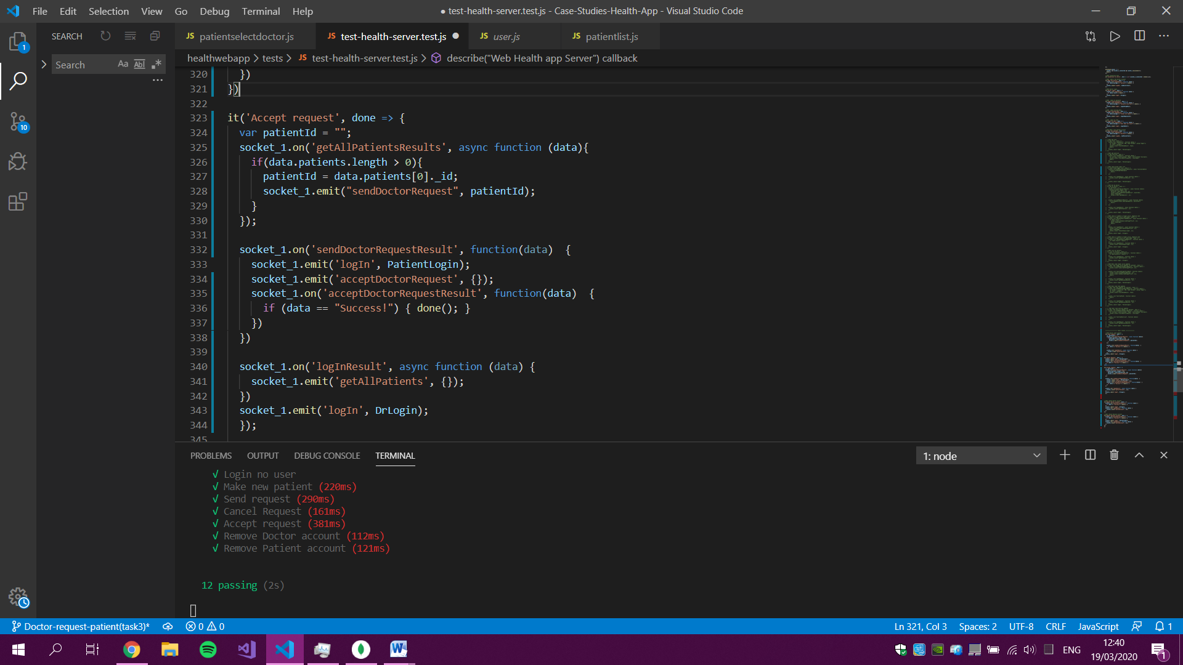

**Test results**

All of the tests ran successfully in an acceptable time.

